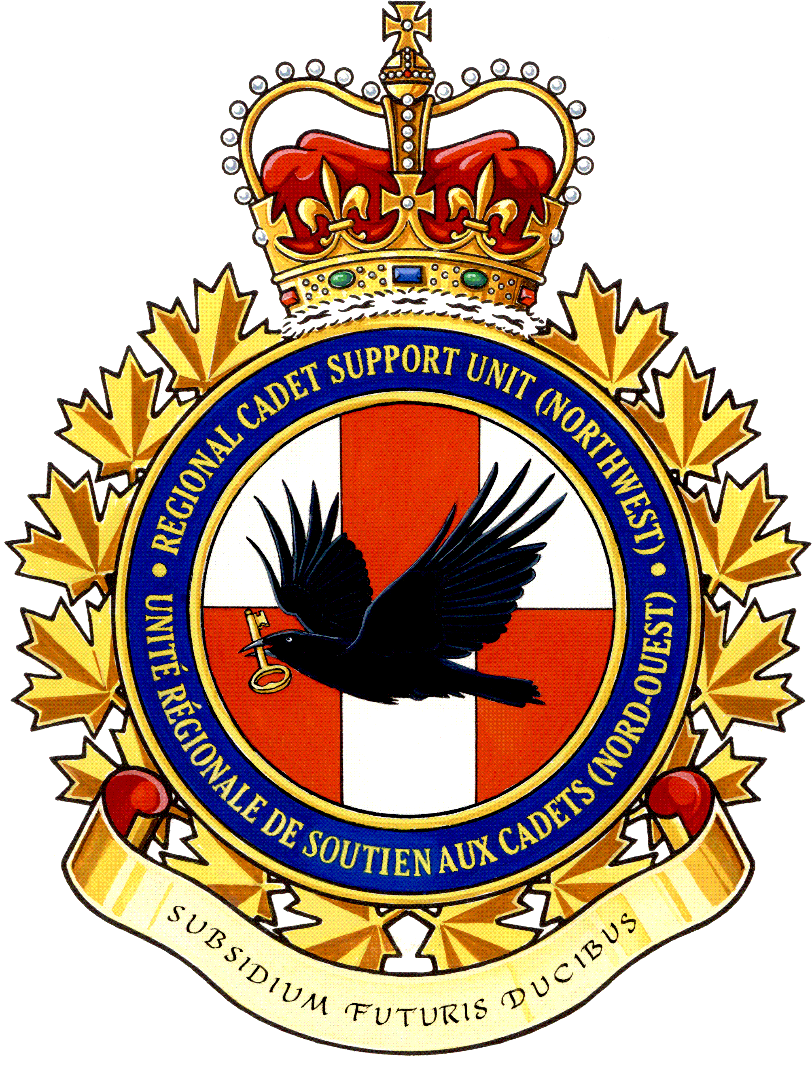
SUMMER TRAINING CHOICES

Level One (Two Weeks)

• General Training Course (GTC)

Minimum Level Two (Three Weeks)

• Basic Drill and Ceremonial Course (BDCC)
• Basic Survival Course (BSC)
• Basic Fitness and Sports Course (BFSC)
• Basic Aviation Course (BAC)
• Basic Aviation Technology and Aerospace
Course (BATAC)
• Military Band - Basic Musician Course (MB-BMC)
• Pipe Band - Basic Musician Course (PB-BMC)

Minimum Level Three (Three and Six Weeks)

• Advanced Aviation Course (AAC) (Three Week Course)
• Drill and Ceremonial Instructor Course (DCIC)
• Survival Instructor Course (SIC)
• Fitness and Sports Instructor Course (FSIC)
• Air Rifle Marksmanship Instructor Course (ARMIC)
• Military Band - Intermediate Musician Course (MB-IMC)
• Pipe Band - Intermediate Musician Course (PB-IMC)

Minimum Level Four (Six Weeks)

• Military Band – Advanced Musician Course (MB-AMC)
• Pipe Band – Advanced Musician Course (PB-AMC)

Staff Cadet (Seven Weeks)

• Ποσιτιονσ αϖαιλαβλε ατ ϖαριουσ Χαδετ Τραινινγ Χεντρεσ

National Courses (Three to Seven Weeks depending on the course / exchange)

• Advanced Aerospace Course (AASC)
• Advanced Aviation Technology Course – Airport Operations (AATC-AO)
• Advanced Aviation Technology Course – Aircraft Maintenance (AATC-AM)
• Glider Pilot Scholarship (GPS)
• Power Pilot Scholarship (PPS)
• International Air Cadet Exchange (IACE)
Name: __________________________________
Level: ___________

1st Choice: ______________________________

2nd Choice: ______________________________

3rd Choice: ______________________________

Additional Choices: ________________________

________________________________________

Any restrictions on dates or special details that we should be aware of:
_______________________________________
_______________________________________
_______________________________________

Level Officer Recommendation:
_______________________________________
_______________________________________
_______________________________________

If applicable:

GPS/PPS: Weight (Kgs) ____ Height (cms) ____

Aviation Technology Courses (AM/AO):

Height _____ Waist ______ Boot Size _______
(cms) (cms) (inches)

Cadet Signature: __________________________

Parent Signature: ________________ _________
(Optional)

