#34 Roland J Groome Squadron
Parent Sponsoring Committee
Meeting Agenda

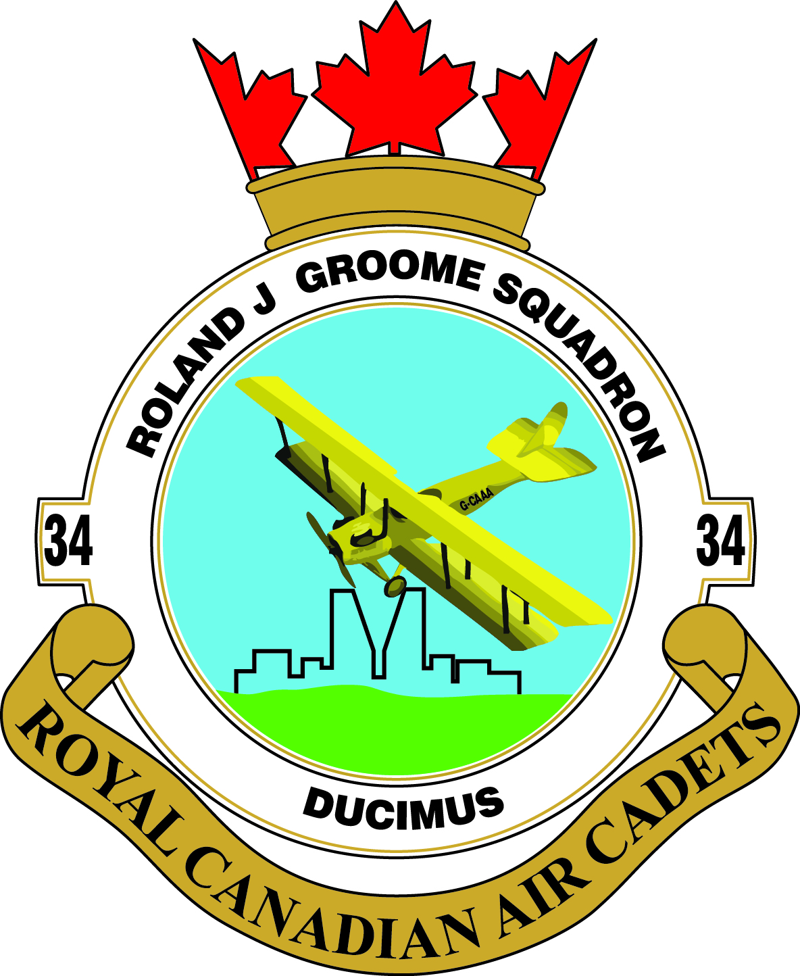

Date March 2, 2015

Call To Order
Review Minutes of Last Meeting
Any additions to the Agenda
Approval of Agenda
Old Business Arising From the Minutes
- Effective Speaking-possible change of date
- Refund from Easter trip
- Ravine Adventures
- New Flag
Treasurers Report – Bob Parker
Car Raffle Report – Kathy Martin
Rider Report-Iain Hall
Parent Screening-Leslee Dykstra
Fundraising-Pat Henneberg/Liza Clark
- Silent Auction
- Cadet Clothing
- Ottenbreit’s Meats
Non-Commissioned Officers (NCO) Report
Commanding Officer (CO) Report
Saskatchewan Air Cadet League Report – John Hicks

New Business
Next Meeting Date – April 6, 2015
Adjournment

