#34 Roland J Groome Squadron
Parent Sponsoring Committee
Meeting Minutes

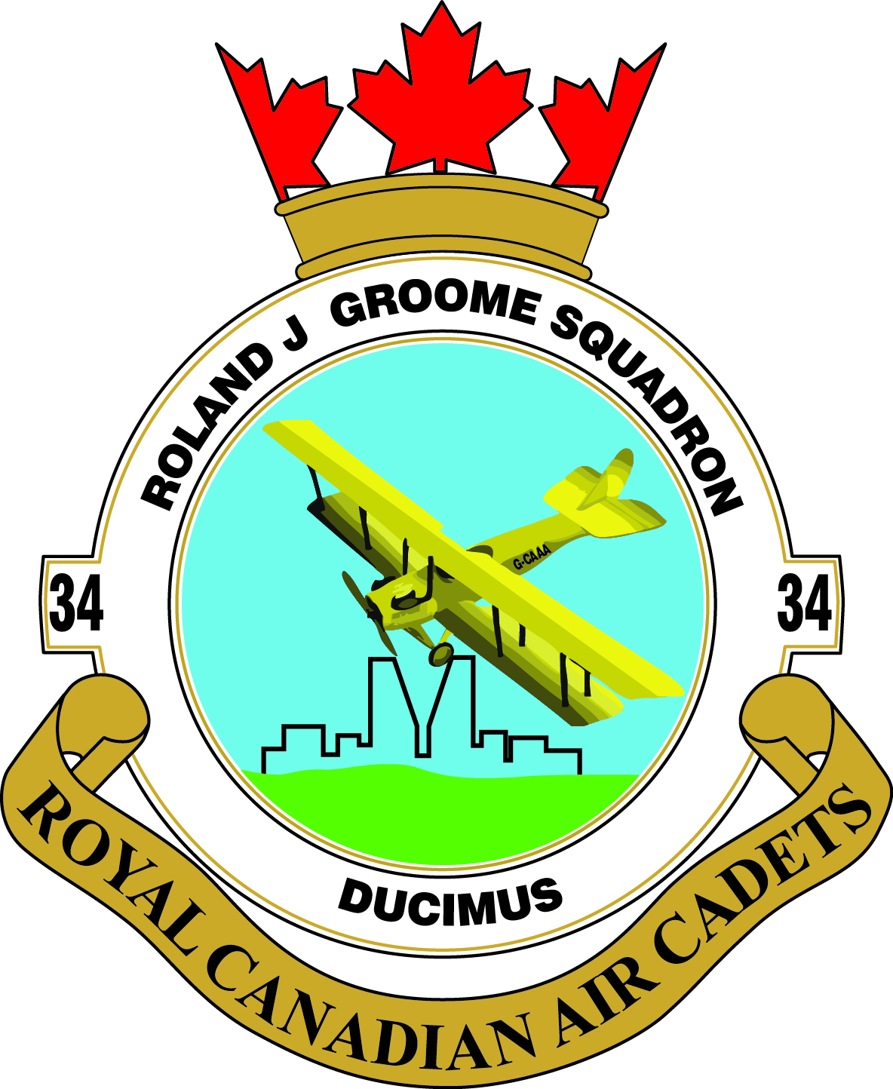

Date Feb 2, 2015

Call To Order
Attendees: Tony Dykstra, Bob Parker, Katherine Martin, Reg Neuberger, Laurie Carlson Berg, Iain Hall, Dallas Belsher, John Hicks, Mark Supel, Helen Zu, Wensley Liu, Liza Clark, Linda Sargent, Len Parker, Leslee Dykstra, Capt. Gary Saxby

Review and Approve Minutes of Last Meeting
Laurie Carlson Berg approved adoption of minutes as presented.
Any additions to the Agenda
New secretary required
New Flag/banner
Old Business Arising From the Minutes
- Luke Towers briefly presented information on changing our email addresses to psc@34rcac.ca and officers@34rcac.ca
Motion to accept customized email address – Liza Clark.
Seconded Laurie Carlson Berg.
- New Parents Handbook is done and is on the website under parents’ section. Kathy Martin to have some copies printed for next parade night.
- Van repair cost was less than estimate by $60.00 and the repair was completed satisfactorily.
Cost of repair was $809.00.
- Ravine Adventures is booked for February 15. DND funds are paying for everything.

- Area Meeting – was attended by Tony, Kathy, Capt. Saxby.
- Discussion: 75th Anniversary poster contest is being sponsored by the Air Cadet League. The deadline is May 1st. Tony to provide copies of the entry form at parade night tonight. First prize is $500.00 and a trip to Ottawa; second prize is $300.00; third prize is $200.00. John Hicks had some ideas for poster themes: Relatives in the military – generations through the ages, History of Air Cadet League – then and now.
- 75th Anniversary pins for Cadets and officers will be available by October, and they will also be available for purchase by the public.
- Other discussions: Casino Initiative Grants – Casino Regina. It is available to non-profits; Kathy to investigate further. Other fundraising ideas: 50/50 progressive raffle tickets, Christmas photo ideas (Whoville), etc.

Treasurers Report – Bob Parker
- We are going paperless, so Bob presented his report via projector. A copy of the report will be sent out with the minutes.
- Easter trip refund has not been resolved; Bob to talk to Capt. Saxby about more contact information.
- Motion to accept the report: Bob Parker, seconded Liza Clark

Car Raffle Report – Kathy Martin
- Laurie Carlson Berg will train for the 2015 year.
- We have tickets. 3/$5.00 – one set only this year.
- Books will be signed out to parents, not Cadets. Lost books were forgiven by the Air Cadet League, but this will not be the case going forward.
- Profit – 1st 3 books per cadet is $5.00/book, 4 or more is $10.00/book.
- Books are to be sold by the end of October.
- Selling ideas: Door to door or at stores/malls, possibly along with a bottle drive, youth must be supervised and within line of sight at all times.
- Publicity ideas were discussed: flyers, TV/radio community calendars/spots.

Rider Report-Iain Hall
- $6080.00 was paid out by cheque for last season.
- 2nd floor beer booth may be available this year. Iain to contact Ray for more info.
Parent Screening-Leslee Dykstra
- We have two new screened parents for a total of 15, and possibly 3 more.

Fundraising-Liza Clark/Pat Henneberg (absent)
- Tumblers – cancelled due to lack of interest.
- Silent Auction – April 11, 2015, $30.00 per ticket
- We have approximately $5000.00 worth of items so far, looking at getting items from the Food Bank; Tyrone Breckinridge may supply some Rider items.
- Wild Game dinner
The event went well; we were paid $800.00, $50.00 less than last year. We were asked to tear down tables and put away chairs, not in our usual scope of duties. Good publicity for us, but do we want the extra work for less pay? We had 13 volunteers.
- Ottenbreits Meat – no report as Pat was absent
- Liza noted that we have plenty of decorative items for events, dances, etc. Do not buy anything more without checking with her first.
- Food Bank donated approximately $2000.00 worth of items for Saskadet, such as housekeeping goods, kitchen items, office supplies. Thanks to Kim Baker at the Food Bank. Some items were shared with 703 Squadron.
- An inventory of items in basement storage needs to be done – Liza to take care of this.
Non-Commissioned Officers (NCO) Report
- Treasurer’s report to be attached to the minutes.
- Dance to be held either end of May or in June after the banquet.
- NCO meeting to be held next week. Bake Sale next Monday for Valentine’s. They hope to hold one every 3 months.
- They are going to establish Task Groups with timelines so that proposed activities get done. A proposal will be given to the PSC and Capt. Saxby.
- Mom’s Pantry – to be done before Easter. Kathy Martin to help out.
- Other Ideas: Menchies’ fundraiser in summer, Family Night BBQ.

Commanding Officer (CO) Report
- Summer training applications have all been sent into Winnipeg. We are the first squadron in Saskatchewan to do so. Replies start coming out in May.
- Sports Competition- Jan 17 in Regina. Looking for Basketball and Volleyball Teams.
- Range will be the same team as last year as no one new is showing up- Feb 21.
- Curling – Feb 28 in Moose Jaw, Jeff to be coach.
- Ravene Adventures - Feb 15, everything is booked.
- Fam Flying- some was done on Jan 24th, but there were aircraft issues, flights to be continued on Feb 7th.
- Effective Speaking- March 7, 2015 at Heritage United Church.
- Stage2 Marksmanship- Feb 21 in Regina.
- Summer Saskadet- June 5-7, 2015.

Saskatchewan Air Cadet League Report – John Hicks
- An idea to increase membership in rural squadrons was put forth. Adopt-a-Squadron: Take a smaller rural squadron with us to a Saskadet camp. More details will be forthcoming for the next meeting.
- Upcoming events: Effective Speaking, Curling, possible Wing Parade in Yorkton.
New Business
- New Secretary – Bonnie Behr has left the group. Motion was passed by Liza Clark that Leslee Dykstra take over Secretary position until the end of this Cadet year. Seconded by Laurie Carlson Berg.
- Elections will take place in May for all positions that are up for renewal after the 2 year mark.
- New Flag – Kathy Martin and Bob Parker will look after ordering a new flag/banner. Cost is $1075.00 plus taxes and shipping from Air Cadet League website. Money from NCO Club plus any donations will be used to fund this purchase.

Other Business
- None at this time.

Next Meeting Date – March 2, 2015
Adjournment 8:35 pm

