First Year Cadet Handbook
Royal Canadian Air Cadets
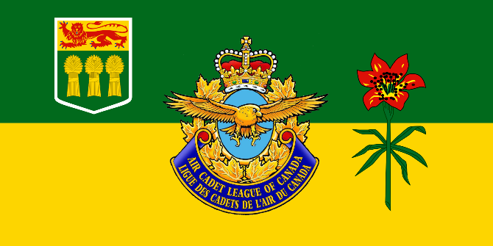
Air Cadet League of Canada – Saskatchewan Provincial Committee
To Learn • To Serve • To Advance
www.SKACL.ca

Preface

Congratulations and welcome to Royal Canadian Air Cadets. We are glad that you have made the choice to join us. As a new cadet in the Squadron there will be a learning curve. The goal of this guide is to give you basic information that will be important in your cadet career. This information supplements the content of level one training, and many of the aspects covered in this guide will be explained in full lessons later. Work hard and good luck on your cadet career.

Motto:
- To Learn, To Serve, To Advance

Aims of the Air Cadet Program:
- To develop in youth the attributes of good citizenship and leadership
- To Promote Physical Fitness
- To stimulate an interest in the air element of the Canadian Forces

Policies

Cadets are subjected to follow the Cadet Administrative and Training Orders (CATOs), national standing orders for the cadet program. All policies of the cadet program are written out in the CATOs. This resource can be found online on www.skacl.ca.

Attendance: An absence is when a cadet misses a mandatory event (or optional event that the cadet has already committed to) without being excused. To be excused, a cadet must inform the Squadron of the reason prior to the event. When planning on being absent for an event, a cadet must be excused. Absences and excessive excused absences will affect opportunities for promotion, awards, opportunities within the Squadron and summer camp acceptance. Furthermore, excess consecutive absences may result in a cadet's release from the Squadron.

Mandatory events include, but are not limited to: regular training nights (once a week), Field Training Exercises (FTX), Tag Day, Remembrance day, etc.

Cell Phones: Cadets cannot use their cell phones during activities such as classes. If problems occur, disciplinary actions may take place on a squadron-by-squadron basis. The Squadron will not be responsible for any lost or damaged devices.

Command and Structure

The cadet program utilizes a paramilitary structure, meaning a military-like structure. Military elements such as ranks, uniforms and the chain of command structure are used. Cadets are not military personnel, but officers are. Officers are the adult staff members of the Squadron and belong to the Cadet Instructors Cadre, a subcomponent of the Canadian Armed Forces Reserve.

Ranks are earned in this system and everyone is referred to by their rank. As a new cadet you have a rank: Air Cadet (Cdt). This is the lowest rank but you may be promoted based on seniority, successful completion of all qualifications, and merit.

Air Cadet ranks in increasing order:

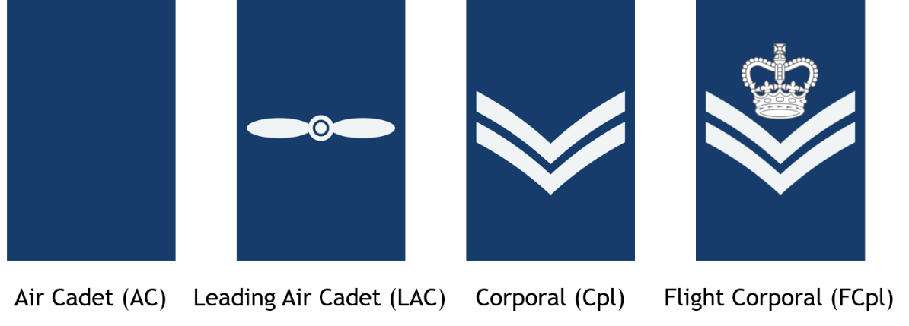
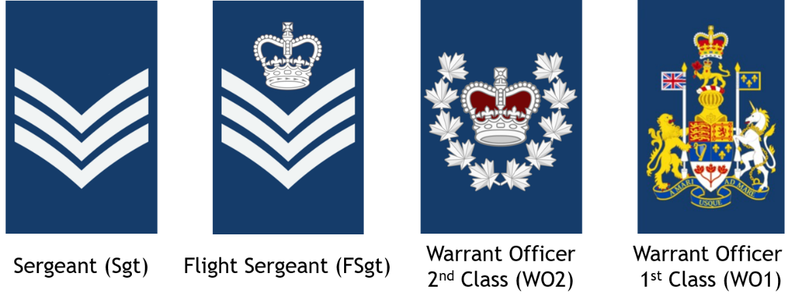
Warrant Officers are the two most senior cadet ranks and are referred to as Sir or Ma’am by those of lower rank.

Royal Canadian Air Force officer ranks in increasing order:

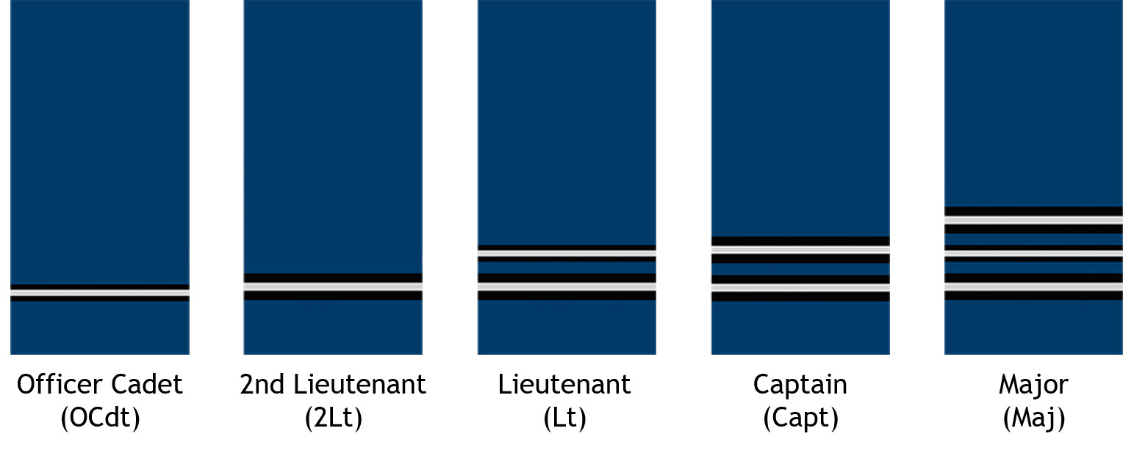
Officers are referred to as Sir or Ma’am and saluted. *OCdt’s are not saluted.
Keeping in line with this military structure, you will be addressed to by your rank and last name. When referring to yourself, you must also use your rank and last name (i.e., when someone asks for your name).

The Squadron also incorporates the chain of command element from the military. This allows for orders to be distributed to all members of the Squadron and for everyone to have a direct and accessible leader. This is an extremely important element of the Squadron and is a crucial foundation upon which the program is delivered to you.

As a new cadet, you will start off at the bottom of the chain. You will be assigned to a flight and be responsible to the Flight Commander (FCmd). Your Flight Commander and senior members of your flight will be your first stop for any questions and advice that you seek.
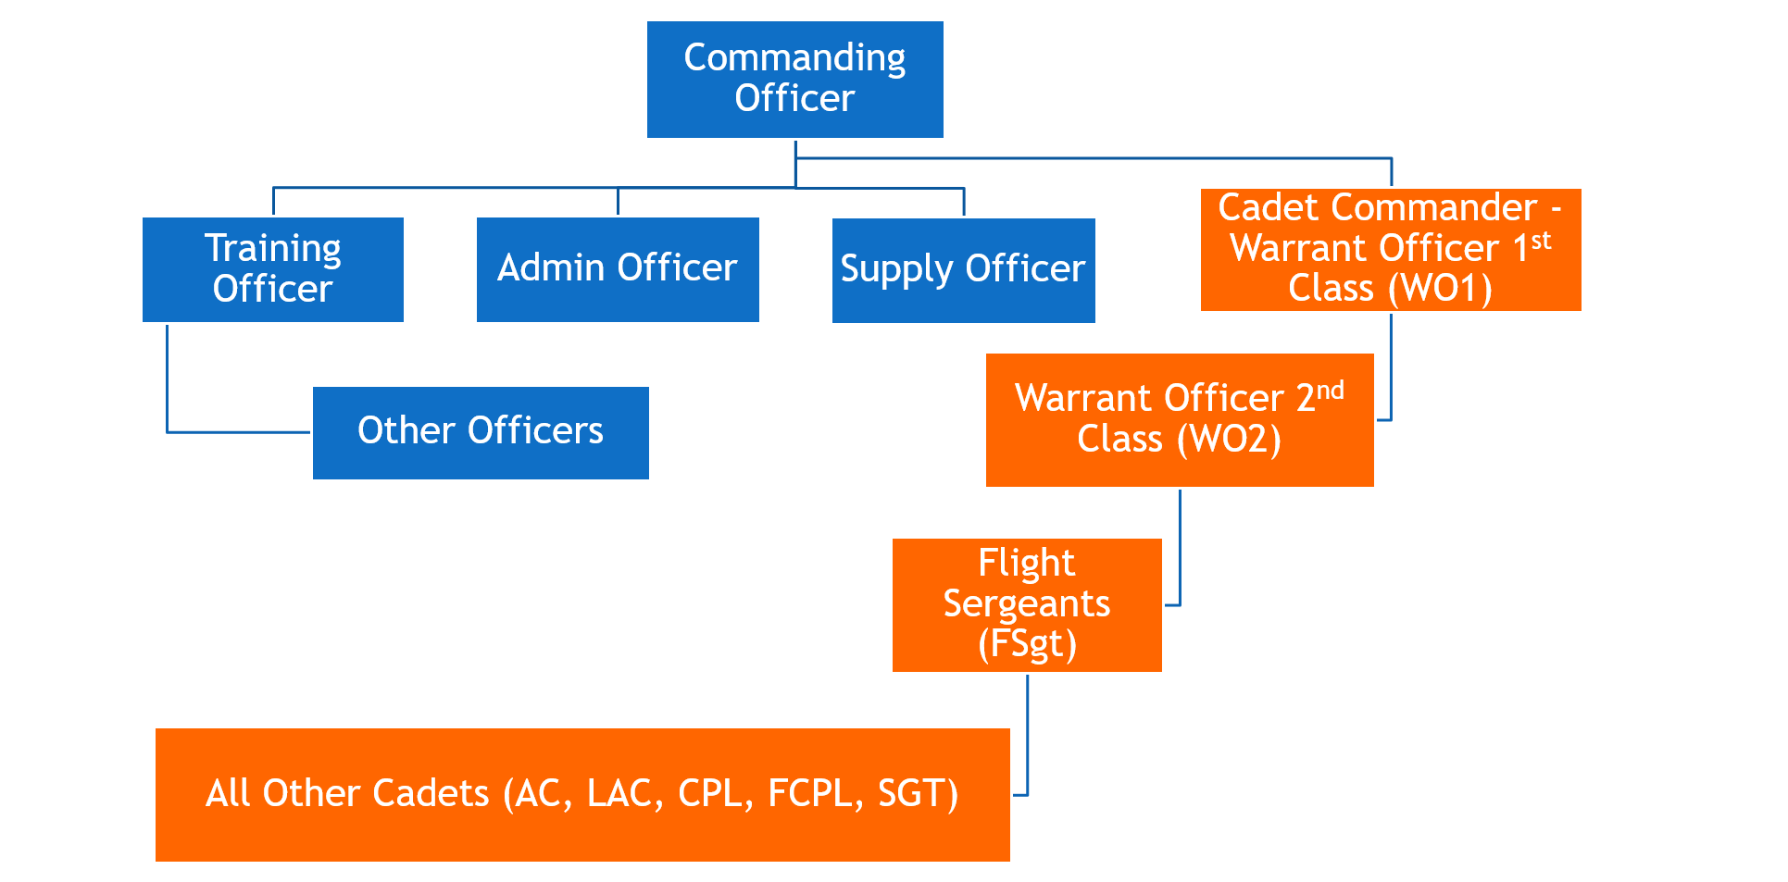

Dress and Deportment
Note: All dress instructions, pictures, diagrams, videos, uniform care instructions are available online at www.skacl.ca.
A uniform will be issued to you while you are a cadet and must be returned upon leaving cadets. While waiting for the uniform to be issued please wear a white long- sleeved shirt, black dress pants and dress shoes.

You must conform to the grooming standards at all times while a cadet. Failure to meet the standards will lead to disciplinary action. Hair must be of a conservative colour and style.

Male cadets must be clean-shaven, with short hair that does not touch the ears and be kept free from the neck to a distance of 2.5 cm (1 in) above the shirt collar. The bulk of the hair must not interfere with the headdress. The bulk of the hair (at any area) may not be greater than 4 cm (1.5 in) in length.
Female cadets must have their hair up in a bun, secured with a hair net and gel. Female cadets who have short hair do not have to secure their hair in a bun if the hair does not extend past the shirt collar. When wearing the uniform, or when wearing civilian clothes on duty, make-up shall be applied conservatively. The use of false eyelashes, heavy eyeliner, any brightly coloured eye shadow, nail polish, bright or vivid lipstick and excessive facial make-up is not acceptable.

Jewelry - The only jewellery that may be worn in uniform shall be a wristwatch, a medical alert bracelet and a maximum of two rings, which are not of a costume jewellery nature. In addition, female cadets in uniform may wear a single pair of plain gold, silver stud or white pearl earrings in pierced ears. Male cadets are not authorized to wear an earring or earrings.

Deportment - When you are in uniform you should present a good appearance. Chewing gum, slouching, hands in pockets, walking arm in arm, and similar actions are not appropriate for a cadet in uniform. The way you behave in uniform will affect what people think of all cadets. The pride you show in your uniform will affect what people think of all cadets. The pride you show in your uniform is a reflection of the pride you have in yourself and your squadron.

Saluting - Cadets salute commissioned officers (officers above the rank of OCdt), the national flag and the playing of a national anthem (Canada’s and other nations’). You only salute when in uniform and wearing a headdress. T talk to an officer, you must first come to attention, salute, then talk.

For more info including badge placement and uniform standards, visit www.SKACL.ca

Training

Your first year will be a lot of fun! Parade nights are regular training nights where you will participate in classes on aviation, aerospace, leadership, fitness & sports, drill, survival, military, and other topics. There are practices on Sundays for extra-curricular teams such as band, drill, marksmanship and flag party (depending on the squadron). You are encouraged to join a team as these will open new opportunities for you. You may have the opportunity to go gliding throughout the year and participate in field training exercises (FTXs). You are also encouraged to apply for a summer training course at one of the Cadet Summer Training Centres (CSTCs) throughout the province. More information about this will be given later in the year.

There are 5 training levels. Each training level takes one year to complete. You are in level 1. Advancement in training levels is independent of rank promotion, for the most part. Rank promotion is based on merit and level completion while level advancement is based off participation, completion of performance checks and attendance in regular training nights. Higher ranks require further vetting of their merit. Completion of certain training levels is a prerequisite for all summer training courses.

Summer training courses run from 2 to 7 weeks. Courses range from topics such as survival training to fitness to music and to aviation related courses and scholarships. Acceptance for courses, especially national courses such as flying scholarships and international exchanges, are very competitive and only the best cadets are selected.

What to Bring Each Week

- Binder
- Pencil & Pen
- Paper
~~

You are now equipped with the tools that you need to become an excellent cadet at your Royal Canadian Air Cadet squadron. While this document cannot teach you everything you need to know, it is the perfect stepping-stone in starting out your cadet career. Remember that the senior cadets around you are experienced enough to guide you through your first year, so don’t be afraid to ask them for help. It is their primary job to ensure that YOU succeed!

Cadets is what you make of it, so apply yourself, work hard and have fun!

Miscellaneous

Common Acronyms
- CO – Commanding Officer
- WO – Warrant Officer
- TrgO – Training Officer
- AdmO – Administration Officer
- StdsO – Standards Officer
- SupO – Supply Officer
- Flt Cmd – Flight Commander
- 2IC – Second-in-command
- CF – Canadian Forces
- CIC – Cadet Instructors Cadre

Military Date & Time
- The 24 hour time is used in Air Cadet Squadrons throughout Canada. When time passes noon, simply subtract 12 to get the time in PM.
- Example: 1930 hrs = 7:30 pm

